Dear Adams12 parents
Prior to participating on a team from Adams 12 Five Star Schools, athletes should provide the Athletic Department with current address, emergency contact, insurance, medical alert and health history information. To expedite this process Adams12 uses an online data entry system.
To enter your information, visit www.swol123.net. The first time you visit the website you will need to enter your personal email address and click Get Password.

Joining SportsWareOnLine
Instruction | Example
Go to www.swol123.net.
Scroll to the middle of the screen and click the Join SportsWare button. | 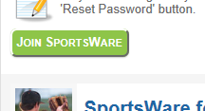
Enter your School ID: Adams12

You should have received a School ID from the athletic trainer. This is required to join the correct school.
Enter your First Name, Last Name, Email address and click the Send button.

Note: Parents with multiple children enrolled will not be able to request to join with the same email address (see the message on the right). The athletic training staff will need to add in the student athlete’s first name, last name and parent email address. The parent will then be able to use the same email address, but must maintain separate passwords. | 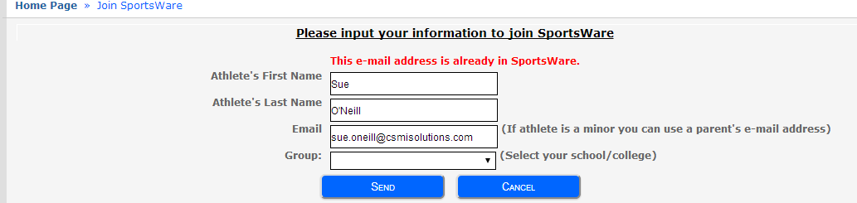
Your request to join SportsWare will then be sent to the Athletic Trainer for review. | 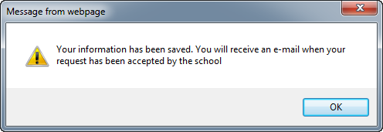
Once your request is accepted you will receive an e-mail with the Subject “SportsWare request accepted”.  Open the e-mail and click the www.swol123.net link to continue to SportsWareOnLine. | 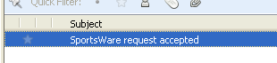

Setting Your Password
Instruction | Example
Go to www.swol123.net
Enter your Email Address and click the Reset Password button.
You will receive and e-mail with the Subject “SportsWareOnLine Password Request”.  Open the e-mail and click on the link to reset your password. Enter your e-mail address, new password and click the Save button. | 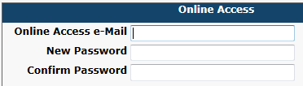

Updating Your Information
Instruction | Example
Go to www.swol123.net
Enter your Email Address and click the Login button.
At the top of the page is the Menu Bar.  My Info: Update your address, emergency contact and insurance information.  Med History: Complete a Medical History questionnaire.  Forms: View/complete required paperwork. Note: SportsWare will also display “You have ? forms to complete/download”.  Print: Print My Info and Medical History data. | 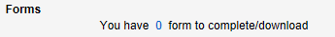

Thank you for your prompt help. If you have any questions, please contact the athletic trainer at your home High School.
Mountain Range High School: Jenny Van Meter –Jenny.vanmeter@childrenscolorado.org 720-972- 6431
Horizon High School: Matt Brewer- Matt.Brewer@childrenscolorado.org 720-972-4507
Legacy High School: Kate Bennett- Kate.brooks@childrenscolorado.org 720-972-6801
Northglenn High School: Kristi Castellaw- Kristi.castellaw@childrenscolorado.org 720- 972-4649
Thornton High School: Ruth Hart- Ruth.Hart@childrenscolorado.org 720-972-2804

Sincerely,
Adams12 Athletics

